# Content decreased

# [[2, Background: Rel-19 RAN1 proposal (by other companies)]]

Referring to Figure 2, aspects of the present disclosure include the support for 8-Rx User Equipment (UE) in the New Radio (NR) standard since Release 15, where the Physical Downlink Shared Channel (PDSCH) can accommodate up to 8 DMRS ports, allowing for a maximum of 8 layers. Furthermore, the Channel State Information (CSI) report can support rank-8 (Type-I). However, it has been noted that no commercial 8-Rx*[Software includes the term]* UE devices are currently available, potentially due to the complexity associated with such UEs. The interior design of these devices may impose additional limitations for 8-Rx configurations, which does not apply to Fixed Wireless Access (FWA) or Customer Premises Equipment (CPE) UEs.In this aspect, proposals in RAN#1#117 (2024-05) aim to reduce complexity by organizing Rx antennas into two groups, rather than utilizing all Rx antennas as a single entity. For example, configurations of 8-Rx and 6-Rx systems are suggested, where the SRS resources for antenna switching are intended for xT6R or xT8R setups. The first SRS port group corresponds to specific SRS ports, and the second group comprises additional SRS ports, with an emphasis on managing mutual interference and ensuring effective resource allocation. The cost associated with this grouping is highlighted, as it is influenced by the transmitted PDSCH signal and the pre-coordinated resource management necessary for each Rx group.

Missed: This feature may represent a separate UE capability that may be configured via radio resource control (RRC), with further details on the extent of RRC configuration pending

# [[3, Background: 2-CW and single-CW receiving]]

The prior solutions include the utilization of two Rx port groups for reducing complexity in MIMO receivers, particularly in scenarios involving 2-CW and single-CW receiving. For cases where the rank exceeds 4, it has been proposed that 2-CW PDSCH is transmitted, targeting each Rx port group respectively, as illustrated in Fig (a). In instances where the rank is less than or equal to 4, the user equipment (UE) may employ log-likelihood ratio (LLR) combining from the demodulation of the two Rx port groups, as depicted in Fig (b). Alternatively, the UE may opt to use a single Rx port group, which may be either a fixed group or the one exhibiting superior signal-to-noise ratio (SNR). These strategies aim to optimize performance while managing the complexities associated with MIMO configurations.

# [[4, Background: SRS for antenna switching (xTyR)]]

The prior solutions include configurations for Sounding Reference Signal (SRS) resources designed for antenna switching in xTyR setups. In an SRS resource set, where the parameter "usage" is configured as "antennaSwitching," a total of \( Q = \frac{y}{x} \) SRS resources are utilized, each comprising \( x \) ports. These \( Q \) SRS resources are transmitted in distinct symbols using Time Division Multiplexing (TDM), with each resource being linked to different User Equipment (UE) antenna ports, thereby ensuring that no two resources share the same port. Previous configurations have adhered to the principle that \( y \) is an integer multiple of \( x \), exemplified by setups such as 1T2R, 2T4R, 1T4R, 2T6R, and 4T8R. However, it is acknowledged that future developments may introduce cases that deviate from this integer-multiple principle, such as 4T6R and 3T8R configurations.

# [[5, Motivation and issue]]

Aspects of the present disclosure include the potential for MIMO receiver complexity reduction through the strategic organization of SRS port grouping in foldable devices. The two Rx antenna groups may correspond to the two SRS port groups and are typically mounted on the two halves of the foldable device, which presents unique challenges due to the physical limitations imposed by the hinge. The RF circuitry may not be able to cross the hinge, necessitating innovative design solutions for SRS port grouping, particularly in configurations such as 3T6R, 4T6R, and 3T8R. Resource management strategies may be essential to enhance signal transmission and mitigate interference, thereby improving overall user experience in foldable phone applications. The effective allocation of resources may also play a significant role in optimizing performance in fixed wireless access scenarios, ensuring that the design meets the specific demands of foldable devices.

# [[6, Proposal for 3T6R]]

Referring to Figure 6, the proposal for 3T6R outlines the strategic grouping of SRS ports within foldable devices. In this aspect, the grouping of the x=3 Tx antenna ports is divided into two parts: 1 and 2. Similarly, the grouping of the y=6 Rx antenna ports is organized as 2 and 4, rather than 3 and 3. The SRS resources, defined as Q=2, are categorized such that each set of 3 ports is allocated into two groups: Group#0 and group#1. Specifically, Group#0 includes SRS#0[0] and SRS#1[0], while group#1 consists of SRS#0[1,2] and SRS#1[1,2]. This configuration is illustrated in the diagram, which displays the first half of the foldable phone corresponding to SRS port group#0 on the left, and the second half corresponding to SRS port group#1 on the right. The visual elements effectively represent the arrangement of the SRS ports, demonstrating the proposed division and organization for enhanced performance in foldable devices.  
Note: Concluding of a paragraph is not as good as prior output that client liked

# [[7, Proposal for 4T6R]]

Client note: As noted above, we want to more positively state that the disclosure includes this idea (and not recite it as a proposal).

Referring to Figure 7(a) and Figure 7(b), aspects of the present disclosure include the proposal for 4T6R configurations, focusing on two alternative SRS resources in a set. For Alt1 SRS, the configuration consists of SRS#0 with 4 ports and SRS#1 with 2 ports. The grouping of these SRS resources is organized into Group#0 and group#1, represented as {SRS#0[0,1,2,3], SRS#1[0,1]} for the first set. In this aspect, the first half of a foldable phone is depicted with SRS port group#0, showcasing SRS#0 ports as {SRS#0[0,1], SRS#1[0]} on the left side. The second half of the foldable phone is illustrated with SRS port group#1, where SRS#0 ports are shown as {SRS#0[2,3], SRS#1[1]} on the right side. For Alt2 SRS, the configuration maintains SRS#0 with 4 ports and SRS#1 with 4 ports, indicating overlapping antenna ports. The grouping is similarly split into Group#0 and group#1, expressed as {SRS#0[0,1,2,3], SRS#1[0,1,2,3]}, emphasizing the overlap in antenna port configurations. In this aspect, the same foldable phone halves are represented, with SRS port group#0 on the left showing {SRS#0[0,1], SRS#1[0,1]} and group#1 on the right displaying {SRS#0[2,3], SRS#1[2,3]}. The proposal outlines how the configurations can effectively utilize the available ports while addressing the unique structure of foldable devices.

# [[8, Proposal for 3T8R (Alt1)]]

Referring to Figure 8, the grouping of the x=3 Tx antenna ports is organized as 1+2, while the grouping of the y=6 antenna ports is arranged as 3+5 (not 4+4). In this aspect, Alt1 SRS comprises 3 SRS resources in a set: SRS#0 with 3 ports, SRS#1 with 3 ports, and SRS#2 with 2 ports, which are non-overlapping. Specifically for Alt1, the grouping of the 3 SRS resources within an SRS resource set is divided into Group#0 and Group#1 ports, defined as {SRS#0[0,2], SRS#1[0,2], SRS#2[0,1]} for the first half of a foldable phone (SRS port group#0) and {SRS#0[1,2], SRS#1[1,2], SRS#2[1]} for the second half (SRS port group#1). The visual representation illustrates the spatial arrangement of the SRS ports, emphasizing the distinct groups and their respective configurations across the foldable device.  
Missing client note: In an alternative (Alt1) grouping strategy for SRS (Sounding Reference Signal) resources, the

# [[9, Proposal for 3T8R (Alt2)]]

Referring to Figure 9, aspects of the present disclosure include a proposal for the SRS (Sounding Reference Signal) configuration in a foldable device utilizing a 3T8R (3 Transmit, 8 Receive) arrangement. The Alt2 SRS configuration presents three SRS resources in a set, specifically SRS#0, SRS#1, and SRS#2, each comprising three ports, with SRS#0 and SRS#1 having overlap ports. In this aspect, the grouping of the two SRS resources, where each resource consists of three ports, is organized into Group#0 and Group#1. Group#0 consists of ports from SRS#0 and SRS#1, namely {SRS#0[0], SRS#1[0], SRS#2[0]}, while Group#1 includes {SRS#1[0,1,2], SRS#0[1,2]}. The term "Overlap" port refers to a distinct combination of SRS resource indices and SRS port indices linked to a shared antenna port, exemplified by {SRS#0, port#1} and {SRS#2, port#1}, which share the same antenna port.The visual representation illustrates two halves of a foldable phone, denoting SRS port group#0 on the left and SRS port group#1 on the right, showcasing the spatial arrangement of the ports and their respective overlap configurations.  
  
Appendix!

# Extracted Images

Image from Slide 2:

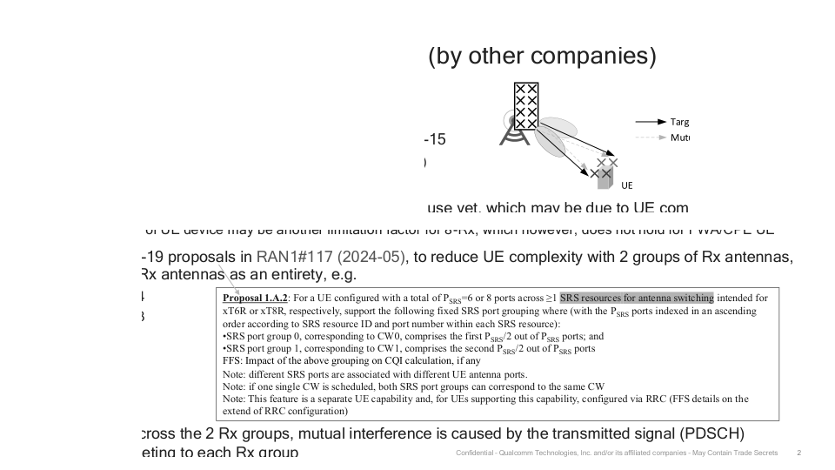

Image from Slide 3:

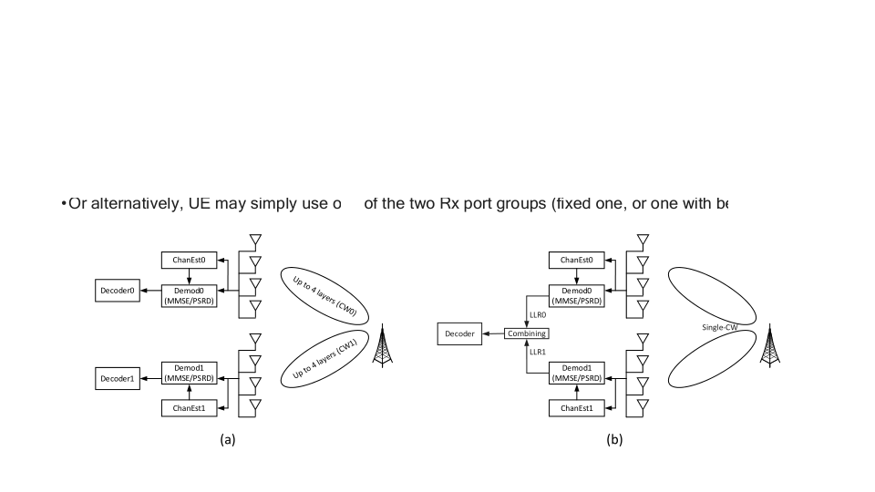

Image from Slide 6:

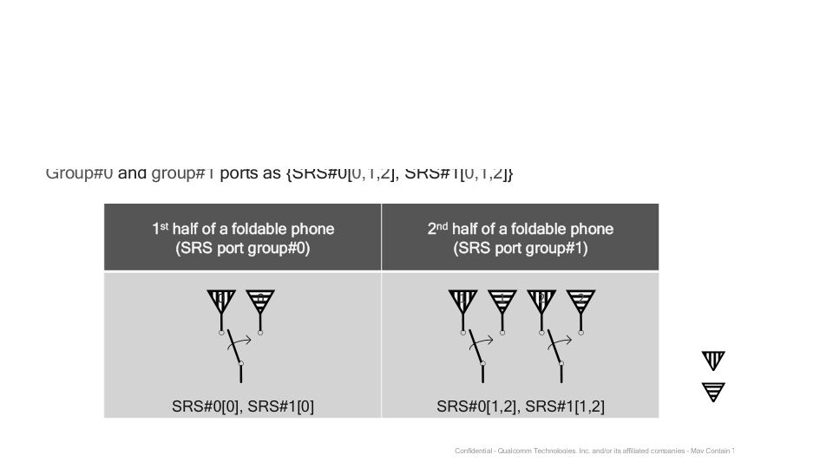

Image from Slide 7:

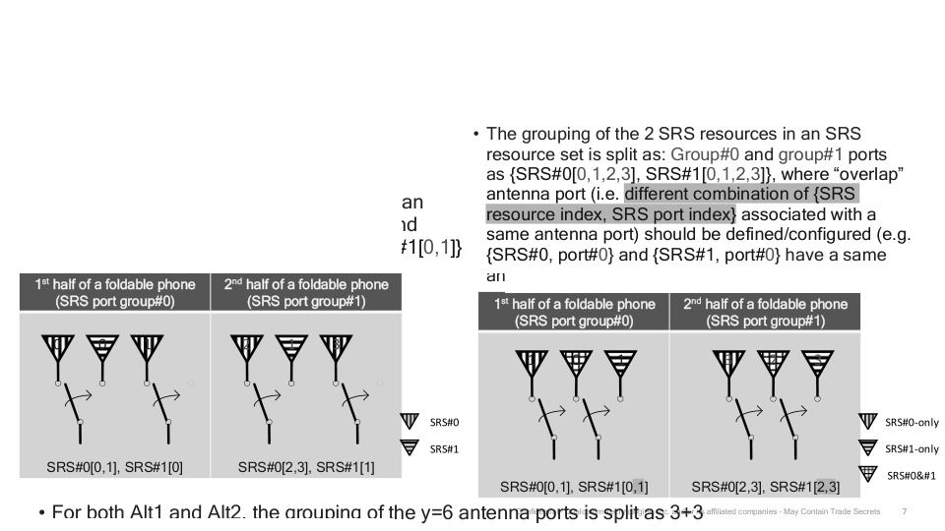

Image from Slide 8:

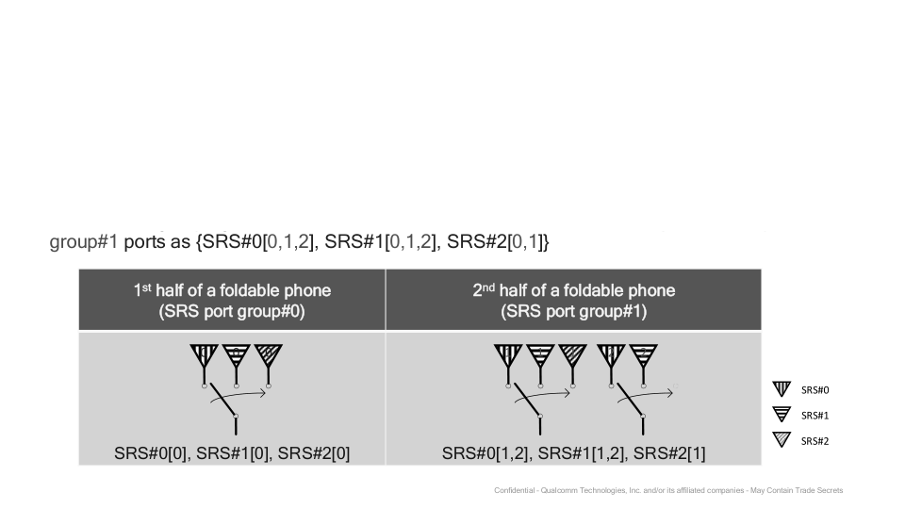

Image from Slide 9:

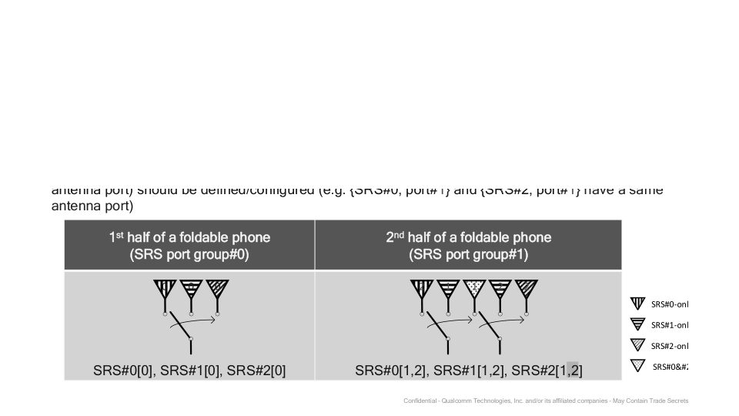

# Overall Theme

### Theme: **Optimizing SRS Port Grouping for Enhanced Performance in Foldable Devices**  
  
#### Key Ideas:  
- **SRS Port Grouping**: The presentation focuses on the strategic organization of Sounding Reference Signal (SRS) ports to optimize performance in foldable phones, particularly in configurations such as 3T6R, 4T6R, and 3T8R.  
- **MIMO Complexity Reduction**: Emphasizes reducing the complexity of Multiple Input Multiple Output (MIMO) receivers by utilizing fixed Rx port groups, enhancing signal processing efficiency.  
- **Antenna Switching**: Highlights the significance of SRS for antenna switching in advanced configurations, ensuring effective resource allocation and improved user experience.  
- **Foldable Phone Design**: Addresses the unique challenges posed by foldable devices, including physical space constraints and RF circuit limitations across hinges, proposing innovative solutions for SRS port grouping.  
- **Resource Management**: Discusses the importance of pre-coordinated resource management to mitigate interference and enhance signal transmission, particularly for fixed wireless access scenarios.  
  
#### Keywords:  
- **SRS (Sounding Reference Signal)**  
- **MIMO (Multiple Input Multiple Output)**  
- **Foldable Phone**  
- **Antenna Switching**  
- **Resource Allocation**  
- **CQI (Channel Quality Indicator)**  
- **RRC (Radio Resource Control)**  
- **Tx (Transmit) and Rx (Receive) Ports**  
- **Group#0 and Group#1**  
- **Overlapping Ports**  
  
#### Visual Elements:  
- **Diagrams of Antenna Grouping**: Illustrations showing the division of Tx and Rx ports into specified groups, contextualized within the foldable phone framework.  
- **Configuration Proposals**: Visual representations of different SRS configurations (3T6R, 4T6R, 3T8R) illustrating port assignments and resource setups.  
- **Technical Framework**: Graphical summaries of the impact of SRS port grouping on overall system performance and user experience.  
  
This cohesive theme encapsulates the core objectives of the presentation, linking the technical aspects of SRS port grouping with practical applications in foldable phone designs while addressing MIMO complexities and resource management strategies.